Evaluation of knowledge about disinfection of dental impressions in several dental schools

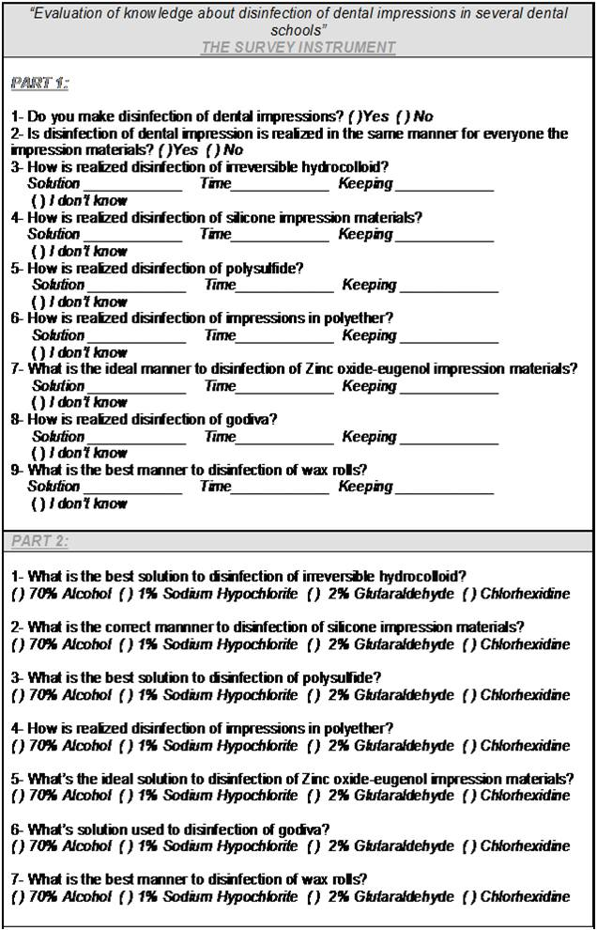
FIGURE 1 - Questionnaire: The first part included descriptive questions and the second multiple choice questions
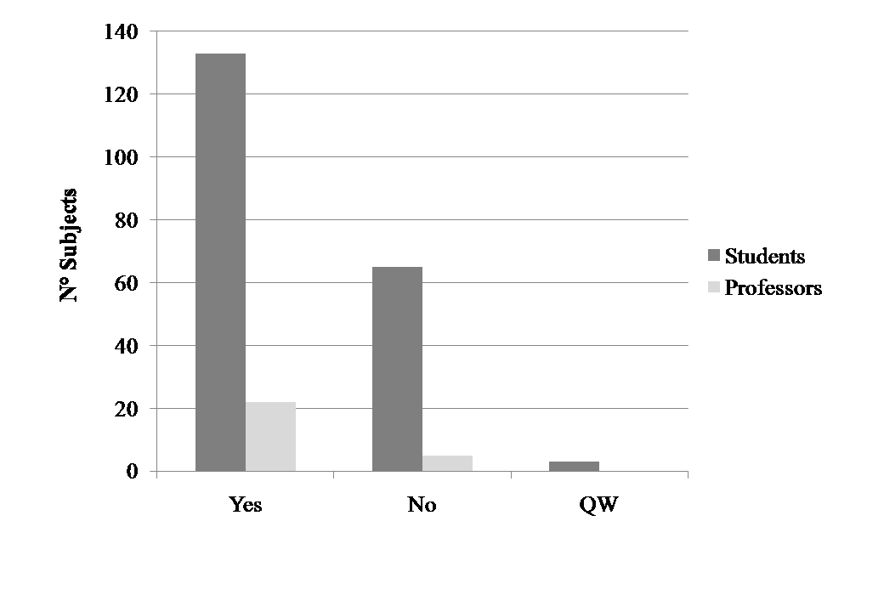
FIGURE 2 - Students and professors that realize disinfection of dental impressions (*QW= questions not answered)

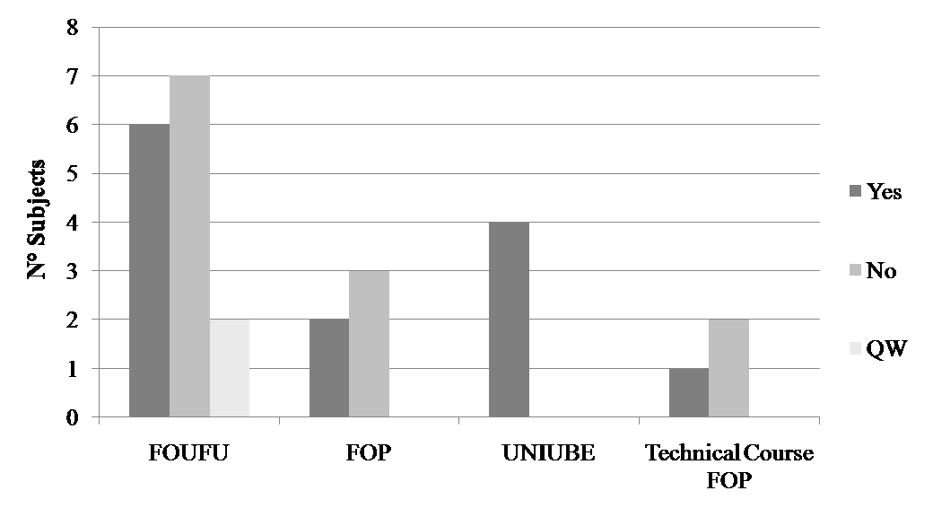
FIGURE 3 - Distribution from the professors as to the institution in which teach and receipt of specific training about disinfection of the impressions (*QW= questions not answered)

LEGENDS
Figures Legends
FIGURE 1- Questionnaire: The first part included descriptive questions and the second multiple choice questions
FIGURE 2 - Students and professors that realize disinfection of dental impressions (*QW= questions not answered)
FIGURE 3 - Distribution from the professors as to the institution in which teach and receipt of specific training about disinfection of the impressions (*QW= questions not answered)

